### 

### Semester One Examination, 2019

### Question/Answer booklet

# MATHEMATICS METHODS

**UNIT 3**

## Section One:

## Calculator-free

|  |  |
| --- | --- |
| **Your Name:** |  |
| **Your Teacher’s Name:** |  |

## Time allowed for this section

Reading time before commencing work: five minutes

Working time: fifty minutes

## Materials required/recommended for this section

***To be provided by the supervisor***

This Question/Answer booklet

Formula sheet

***To be provided by the candidate***

Standard items: pens (blue/black preferred), pencils (including coloured), sharpener, correction fluid/tape, eraser, ruler, highlighters

Special items: nil

## Important note to candidates

No other items may be taken into the examination room. It is **your** responsibility to ensure that you do not have any unauthorised material. If you have any unauthorised material with you, hand it to the supervisor **before** reading any further.

|  |  |  |  |  |  |
| --- | --- | --- | --- | --- | --- |
| Question | Marks | Max | Question | Mark | Max |
| 1 |  | 6 | 5 |  | 6 |
| 2 |  | 6 | 6 |  | 10 |
| 3 |  | 8 | 7 |  | 10 |
| 4 |  | 6 |  |  |  |

**Structure of this paper**

|  |  |  |  |  |  |
| --- | --- | --- | --- | --- | --- |
| Section | Number of questions available | Number of questions to be answered | Working time (minutes) | Marks available | Percentage of examination |
| Section One:  Calculator-free | 7 | 7 | 50 | 52 | 34 |
| Section Two:  Calculator-assumed | 13 | 13 | 100 | 104 | 66 |
|  |  |  |  | **Total** | 100 |

**Instructions to candidates**

1. The rules for the conduct of the Western Australian Certificate of Education ATAR course examinations are detailed in the *Year 12 Information Handbook 2019*. Sitting this examination implies that you agree to abide by these rules.
2. Write your answers in this Question/Answer booklet.
3. You must be careful to confine your answers to the specific questions asked and to follow any instructions that are specific to a particular question.
4. Additional pages for the use of planning your answer to a question or continuing your answer to a question have been provided at the end of this Question/Answer booklet. If you use the space to continue an answer, indicate in the original answer space where the answer is continued, i.e. give the page number.
5. **Show all your working clearly.**Your working should be in sufficient detail to allow your answers to be checked readily and for marks to be awarded for reasoning. Incorrect answers given without supporting reasoning cannot be allocated any marks. For any question or part question worth more than two marks, valid working or justification is required to receive full marks. If you repeat any question, ensure that you cancel the answer you do not wish to have marked.
6. It is recommended that you **do not use pencil**, except in diagrams.
7. The Formula sheet is **not** to be handed in with your Question/Answer booklet.

**Section One: Calculator-free (52 Marks)**

This section has **seven** questions. Answer **all** questions. Write your answers in the spaces provided.

Spare pages are included at the end of this booklet. They can be used for planning your responses and/or as additional space if required to continue an answer.

● Planning: If you use the spare pages for planning, indicate this clearly at the top of the page.

● Continuing an answer: If you need to use the space to continue an answer, indicate in the original answer space where the answer is continued, i.e. give the page number. Fill in the number of the question that you are continuing to answer at the top of the page.

Working time: 50 minutes.

**Question 1 (6 marks)**

**Differentiate** the following with respect to :

1. $e^{x}\sin{(x^{2}+2)}$ (2 marks)

1. $\frac{\cos{x}}{x^{2}+5}$ (do not simplify) (2 marks)

1.  (2 marks)

**Question 2 (6 marks)**

“Blood flow” is defined as the volume $V$ of blood flowing through an artery per unit of time. It can be modelled by the formula $V=kr^{3}$, where $r$ is the radius of the artery and $k$ is a constant.

1. By what fraction is the blood flow in the artery reduced when its radius is halved?

(2 marks)

1. Use the incremental formula to estimate the percentage increase required in the radius of a partially clogged artery to produce a 6% increase in the blood flow. (3 marks)
2. Explain why the incremental formula does not give a good estimate for the change in $V$ in part (a). (1 mark)

**Question 3 (8 marks)**

Determine the following:

1. $\frac{d}{dx}(e^{2x}\sin{3x})$ (2 marks)
2. $\frac{d}{dx}(e^{2x}\cos{3x})$ (2 marks)

Hence, determine the following integral by considering **both expressions** above.

1. $\int_{0}^{\frac{π}{2}}{13e^{2x}\cos{3x}}dx$ (4 marks)

**Question 4 (6 marks)**

The amount of pollution, $P$, in tonnes, to build $x$ thousands number of transistors by an electronic manufacturer, is given by the following formula:

$$P\left(x\right)=\frac{e^{x}}{x^{3}}$$

where $0<x≤5.5$ thousands.

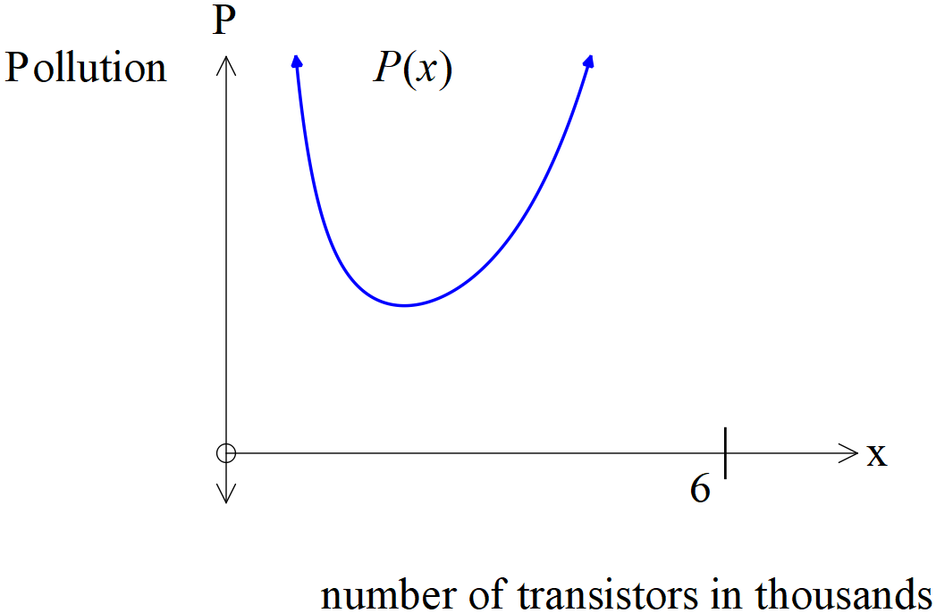

(a) Describe how the pollution changes as the number of transistors made, varies from $0<x≤5.5$  
 thousands. (2 marks)

(b) Using calculus, determine the number of transistors that will minimize the pollution produced. (4 marks)

**Question 5 (6 marks)**

Twenty teachers have been marking the same set of exam papers and after double checking it was found that the teachers made the following number of errors,   
1, 1, 3, 1, 4, 4, 1, 3, 5, 1, 2, 2, 4, 4, 5, 0, 6, 5, 5, 5.

Let $X=$ the number of errors of a teacher.

(a) Construct a table that defines the **probability distribution** of $X$. (3 marks)

(b) Use the probability distribution above to show how to evaluate the expected value of $X$. State this value. (3 marks)

**Question 6 (10 marks)**

In a shop an average of 1 out of 5 pay with cash, 3 out of every 5 customers use a credit card, and the rest use a debit card to pay. A single customer is selected from the shop. The random variable $X$ is defined as the number of customers who pay with cash.

1. Complete the probability distribution for $X$ shown below. (2 marks)

|  |  |  |
| --- | --- | --- |
| $$x$$ | $$0$$ | $$1$$ |
| $$P(X=x)$$ |  |  |

1. State the distribution of $X$. (1 mark)
2. Determine the mean and standard deviation of the distribution. (2 marks)

Four customers are waiting in a queue to pay. The random variable $Y$ is defined as number of customers from this queue who pay with **credit card**.

1. State the distribution of $Y$, including its parameters. (2 marks)
2. Evaluate the probability of at most one customer paying with credit card. (3 marks)

(No need to simplify)

**Question 7 (10 marks)**

Consider a smooth and continuous function $f(x)$ where $f\left(-5\right)=0=f\left(0\right)=f\left(7\right)=f(10)$, and . It is known that $f\left(x\right)≥0$ for $-5≤x≤0$ and $7≤x≤10$ with  for all other values. It is also given that $\int_{-5}^{10}{f(x)}dx=19$ and $\int_{0}^{7}{f(x)}dx=-6$ and $\int_{7}^{10}{f(x)}dx=15$.

Determine the following:

(a) $\int_{-3}^{4}{f'(x)}dx$ (2 marks)

(b) $\int_{-5}^{7}{f(x)}dx$ (2 marks)

(c) the stationary points of $g(x)$ given that $g\left(x\right)=\int_{-5}^{x}{f(t)}dt$ with $-5≤x≤10$ (3 marks)

It is known that  for  and  for .

1. Determine the area under the curve  from . (3 marks)

**End of questions**

Additional working space

Question number: ________